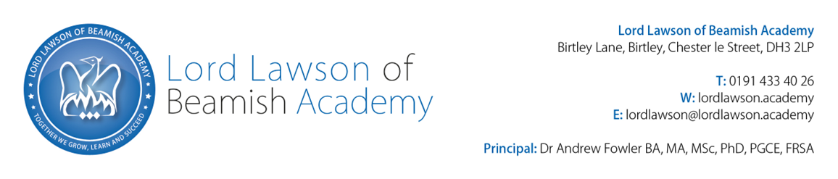

Lord Lawson of Beamish Academy: Personal Specification
Higher Level Teaching Assistant - EBSA

 | Attribute | Essential/ Desirable | Assessment
Qualifications and Education
1. | English and Maths to GCSE standard | E | A/I
2. | Meet Higher Level Teaching Assistant standards or equivalent qualification (NVQ Level 4/5) | E | A/I
3. | Training in relevant specialist skills | E | A/I
4. | Full driving license or access to mobility support | E | A/I
5. | Recognised mental health qualification or similar qualification or experience | D | A/I
6. | Willingness to engage in further professional development as well as improving own knowledge and practice, including responding to advice and feedback | D | A/I
Knowledge and Skills
8. | Effective use of ICT to maintain records and to support learning | E | A/I/E
9. | Understanding of the impact of social, emotional and mental health (SEMH) needs on learning and development and access to the curriculum | E | A/I/E
10. | Good understanding of the principles of child development, learning processes and barriers to learning | E | A/I/E
11. | Good understanding of the principles of SEN Code of Practice, learning processes and SEND procedures, to support learners in accessing the curriculum | E | A/I/E
12. | Working knowledge of national/foundation stage curriculum and other relevant learning programmes and strategies including Post 16 | E | A/I/E
13. | Good understanding of social, emotional and mental health needs | E | A/I/E
14. | Ability to adapt learning outcomes to suit individual children and young people | D | A/I/E
15. | Robust knowledge of relevant legislation/codes of practice relating to safeguarding children and young people | D | A/I/E
16. | Experience of working with anxious students | D | A/I/E
17. | Experience of working across primary and secondary phases | D | A/I/E
18. | Excellent literacy and numeracy skills | D | A/I/E
19. | Working with external agencies | D | A/I/E
Experience
20. | Of working within an educational setting | E | A/I/E
21. | Of working independently and as part of a team | E | A/I/E
22. | Of working with children and young people with social, emotional and mental health needs and/or social and communication difficulties | E | A/I/E
23. | Devising, planning, and delivering successful 1-1 and small group activities around SEMH | E | A/I/E
24. | Of report writing | D | A/I/E
25. | Of coaching and modelling to other staff | D | A/I/E
26. | Of working in a specialist (SEMH) provision | D | A/I/E
27. | Demonstration of excellent behaviour management skills | E | A/I/E
Personal Qualities
30. | Disposition should be positive, patient, calm, caring, understanding, with a good sense of humour | E | A/I/E
31. | Work well under pressure and to meet deadlines | E | A/I/E
32. | Able to work constructively as part of a team or independently | E | A/I/E
33. | Excellent communication skills and able to communicate effectively, sensitively and with empathy with students who have SEMH needs | E | A/I/E
34. | Recognise and respect the contribution parents and carers can make to the development and wellbeing of students | D | A/I/E
36. | To have high expectations and standards of oneself and students | D | A/I/E
37. | Ability to establish fair, respectful, supportive and constructive relationships with students | D | A/I/E
38. | Commitment to promoting equal opportunities and meeting individual needs | D | A/I/E

Assessment and evidence: A = Application; I = Interview process; E = Exercise

